**GitHub CLI**

The **GitHub CLI** (Command Line Interface), also known as gh, is a tool that lets you interact with GitHub directly from your terminal or command line interface.

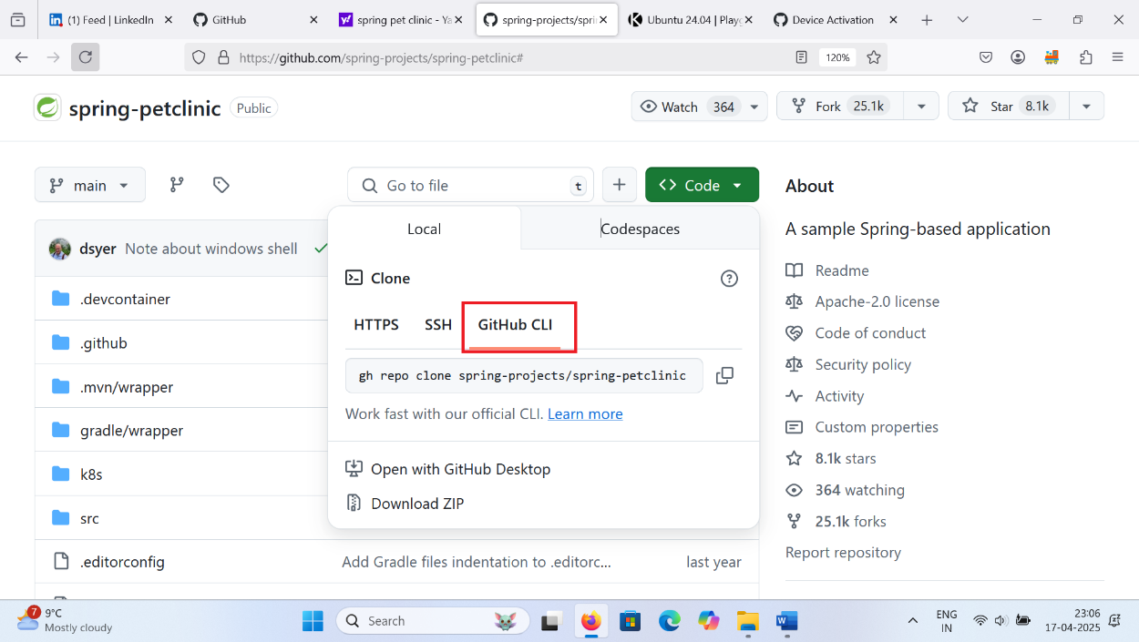

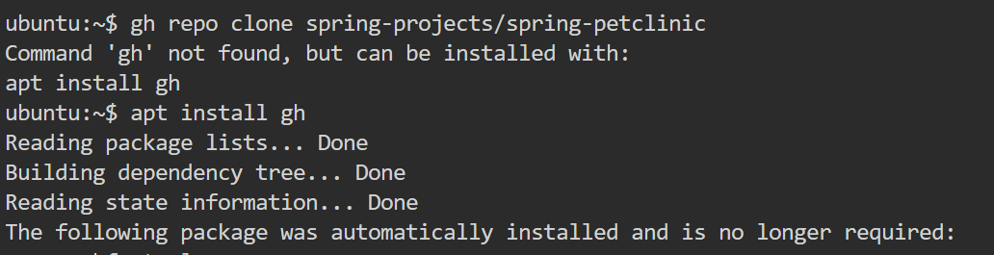

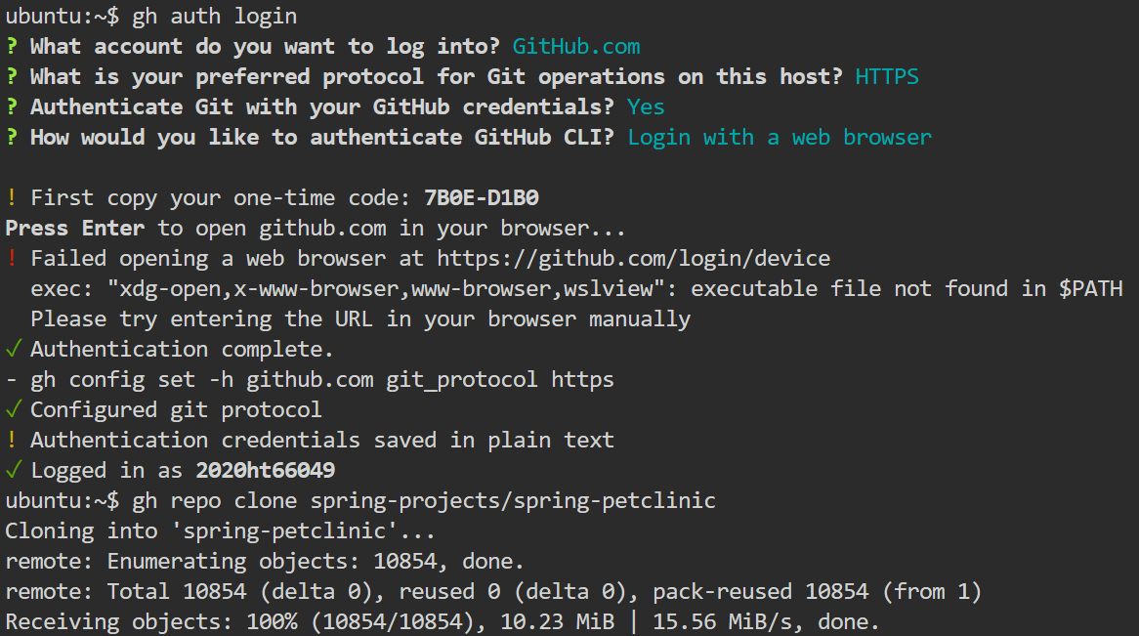

**GitHub CLI Cheatsheet**

